EXPT NO: 4 | TRANSFER LEARNING USING PRE-TRAINED VISION MODELS FOR IMAGE RECOGNITION
DATE: 17.8.26

PRE-LAB QUESTIONS

1. What is transfer learning in deep learning?
Transfer learning is a technique where a model trained on one large dataset is reused for a different but related task. The pre-trained model provides useful features that can be adapted to the new dataset.

2. What are the advantages of using pre-trained models over training from scratch?
Pre-trained models require less training time, need less data, provide better initial accuracy, and reduce computational requirements compared to training a model from scratch.

3. What is the role of fine-tuning in transfer learning?
Fine-tuning involves training some of the layers of a pre-trained model on the new dataset. It helps the model adapt its learned features to the specific image recognition task.

4. Name any three popular pre-trained computer vision models.
Three popular pre-trained computer vision models are:
1. ResNet-50
2. AlexNet
3. VGGNet

5. What is the purpose of Hugging Face and how is it useful in deep learning?
Hugging Face provides a large collection of pre-trained machine learning and deep learning models. It makes it easier to load, use, test, and fine-tune models for tasks such as image classification and natural language processing.

AIM
To implement transfer learning using pre-trained vision models for image recognition and evaluate their performance on real-world image datasets.

SOFTWARE REQUIREMENTS
- Python
- TensorFlow/Keras or PyTorch
- Google Colab
- Hugging Face Transformers
- Kaggle Dataset
- Matplotlib
- GitHub

OBJECTIVES
Students will be able to:
- Understand the concept of transfer learning.
- Apply pre-trained vision models for image recognition.
- Fine-tune models such as ResNet or AlexNet.
- Utilize Kaggle datasets and Hugging Face vision models.
- Compare transfer learning performance with custom CNN models.

PROCEDURE
PART A: DATASET PREPARATION
Perform the following tasks:
- Download an image dataset from Kaggle.
- Load and preprocess the images.
- Split the dataset into training, validation, and testing sets.

PART B: IMPLEMENTING TRANSFER LEARNING
Load a pre-trained model such as:
- ResNet-50
- AlexNet
Replace the final classification layer according to the dataset classes.
Freeze the feature extraction layers.
Compile the model.

PART C: MODEL TRAINING AND PERFORMANCE EVALUATION
Train the transfer learning model.
Record:
- Training accuracy
- Validation accuracy
- Training loss
- Validation loss
- Test accuracy
Visualize:
- Accuracy vs Epoch
- Loss vs Epoch

PART D: USING HUGGING FACE PRE-TRAINED MODELS
Perform the following tasks:
- Load a pre-trained vision model from Hugging Face.
- Perform image classification on sample images.
- Compare predictions with the transfer learning model.
- Document observations and upload the notebook to GitHub.

CODE:
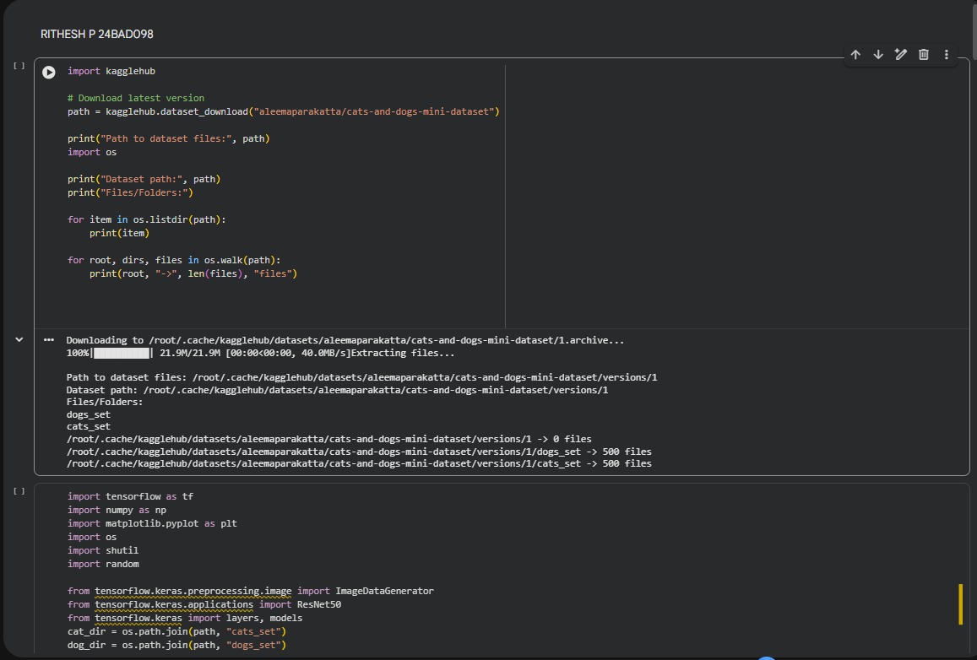
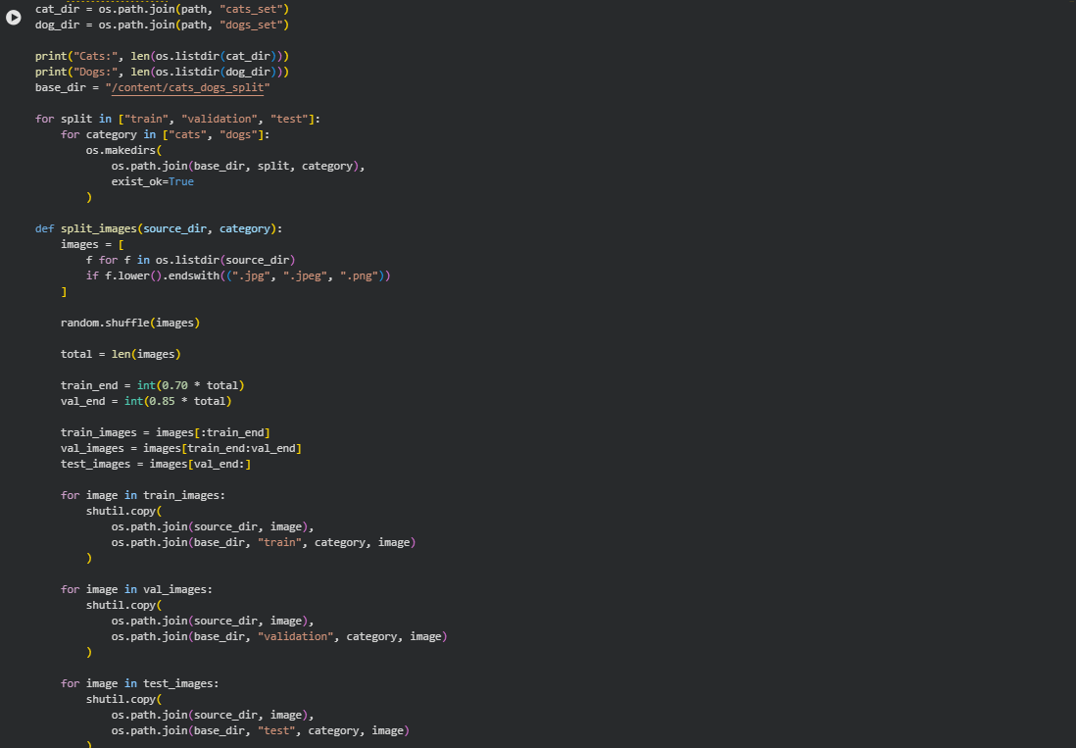
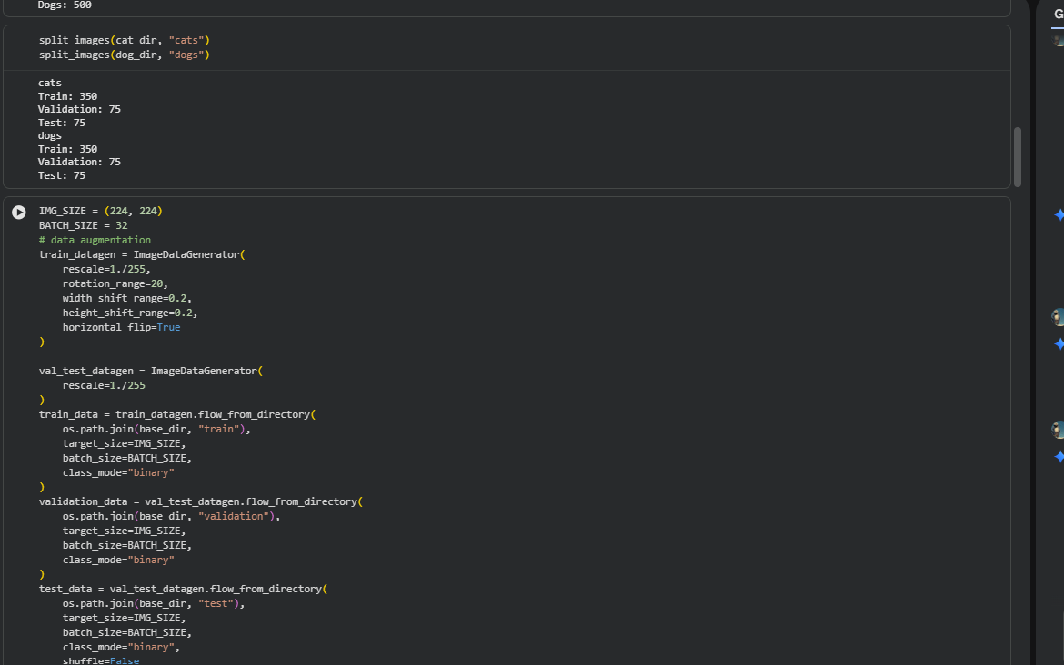
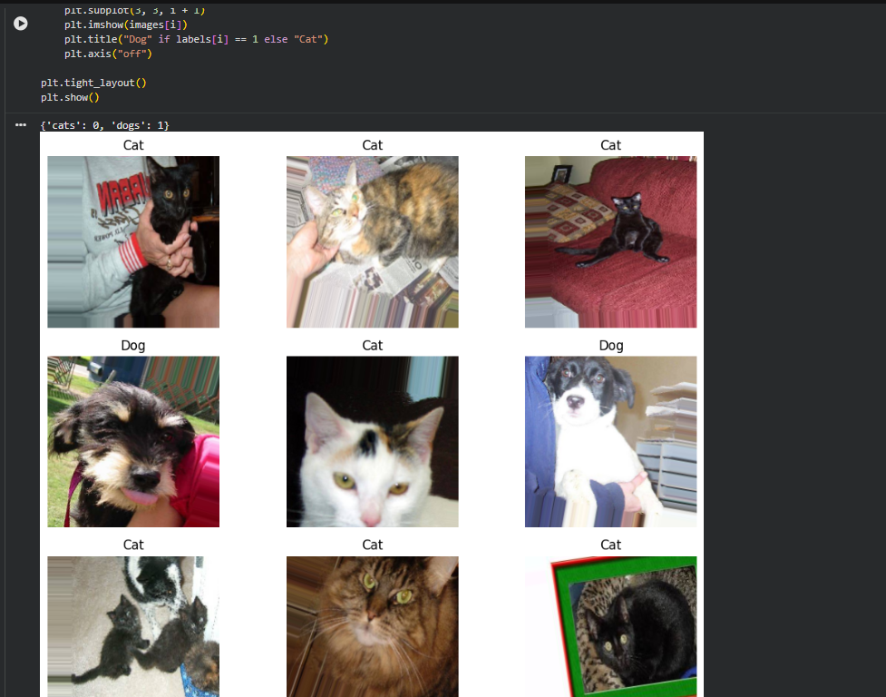
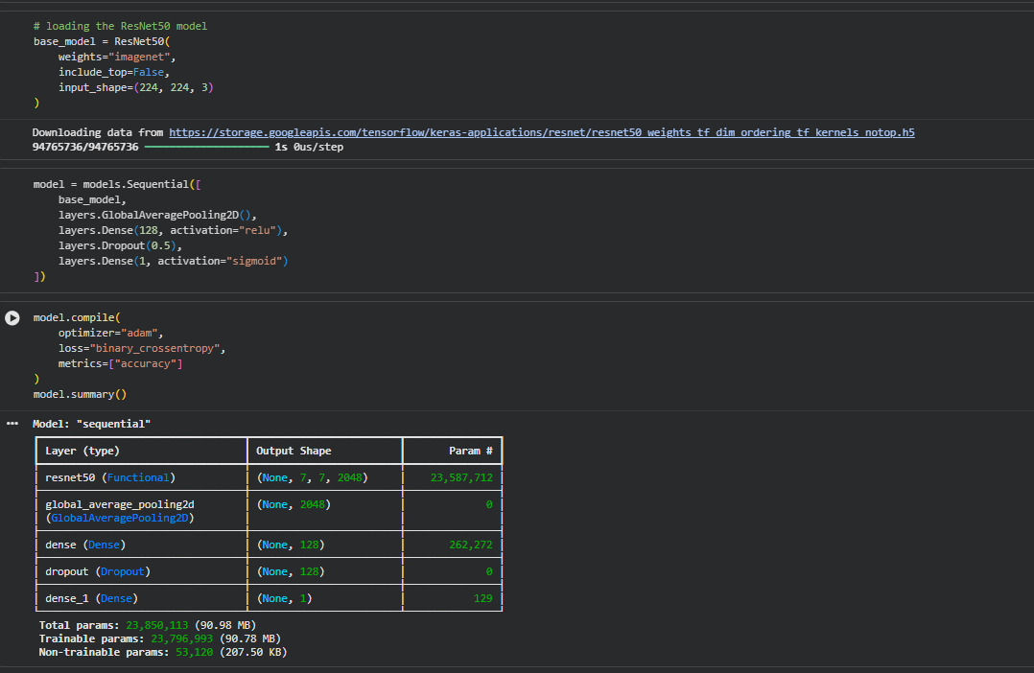
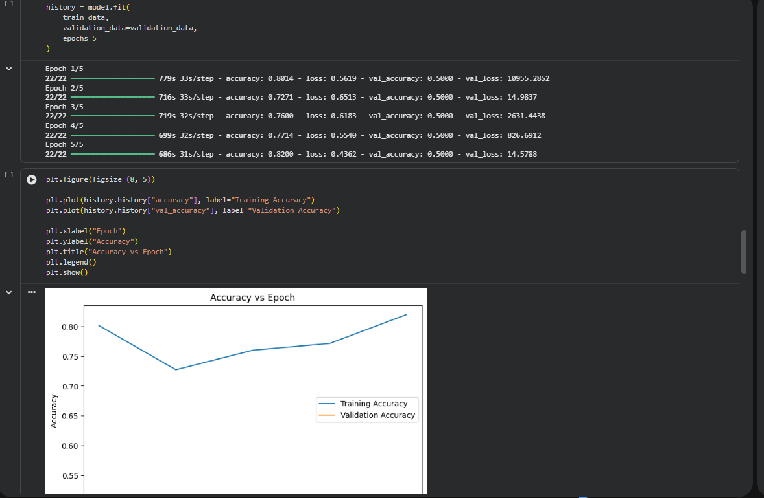
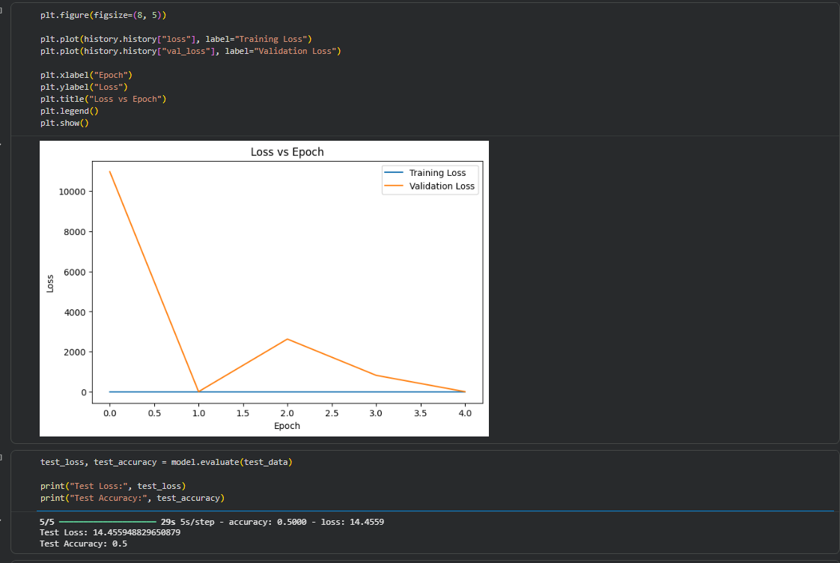
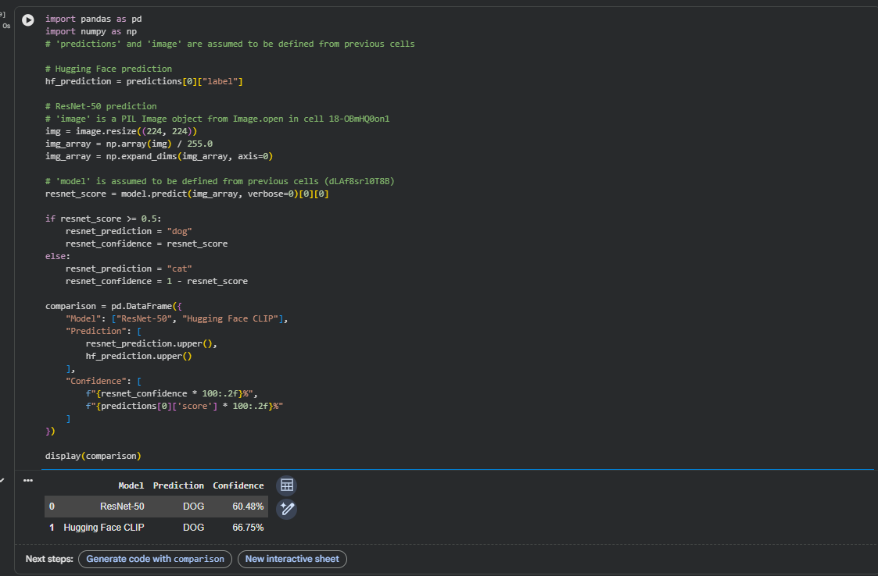

EXPECTED OUTCOME
Students will understand the advantages of transfer learning and gain practical experience in fine-tuning pre-trained vision models from TensorFlow/PyTorch and Hugging Face for image recognition tasks.

POST-LAB QUESTIONS

1. What are the advantages of transfer learning compared to training a CNN from scratch?
Transfer learning reduces training time, requires less training data, provides better performance, and reduces computational requirements. It also allows the model to use useful features learned from large datasets.

2. Why are pre-trained models able to achieve higher accuracy with fewer training epochs?
Pre-trained models have already learned important features such as edges, shapes, textures, and patterns from large datasets. Therefore, they require fewer epochs to adapt these features to a new dataset.

3. Compare the performance of the transfer learning model with the CNN implemented in the previous experiment.
The transfer learning model generally provides better accuracy and faster convergence than a CNN trained from scratch. It can achieve good performance with fewer training epochs because it starts with previously learned features.

4. What is the purpose of freezing layers during transfer learning?
Freezing layers prevents their weights from being updated during training. This preserves the useful features learned by the pre-trained model and reduces training time and computational requirements.

5. How can Hugging Face simplify the deployment and experimentation of vision models?
Hugging Face provides ready-to-use pre-trained vision models and simple APIs for loading and testing them. It makes experimentation, image classification, model comparison, and deployment easier.

ASSESSMENT
Description | Max Marks | Marks Awarded
Pre Lab Exercise | 5
In Lab Exercise | 10
Post Lab Exercise | 5
Viva | 10
Total | 30
Faculty Signature

